

V 1.2
June 2026
XStep Design Specification
SMPL Header: BOM Details

1 Purpose 3
2 Overview 3
3 Reasons for developing 4
4 Authorization 4
5 Assumptions/ Dependencies 4
6 XStep Layout Design 5
7 Function Module(s) 5
8 Pseudocode 7
9 Configuration Specification 14
10 Test Scenarios 14
11 Revision History 15

Purpose
This document outlines the design, along with the configuration specifications for the XStep “SMPL Header: BOM Details”.

Overview
This SMPL Header: BOM Details XStep is designed to display the Bill of Materials that is required to complete the process order. This XStep includes a dynamic table that retrieves and displays the most up-to-date data through the activation of a function module.
The XStep contains the following input parameters:
- IV_HEADER - This can be changed in SiMPL MBR to display specific header text for the XStep
- IV_INSTR - This can be changed in SiMPL MBR to display a specific set of instructions for the XStep that will be displayed below the header
- IV_PH_BOM - This can be changed in SiMPL MBR to display whether the BOM is phase specific. In this case this parameter will be authored as “No”.
- IV_SIGN – This can be changed in SiMPL MBR to author standalone signatures as part of the xstep.
This XStep is executed by the operator in a single stage - BOM Details.
BOM Details
The operator executes the “Get BOM Items” button:
- Get BOM Items - Function Button
The button is linked to the function module ZSMPL_FM_GET_PHASE_PO_ITEMSEBR that retrieves the following information:
- “Material” - Output
- “Material Description” - Output
- “Batch” - Output
- “BOM Qty” - Output
- “UoM” - Output

Functional Design
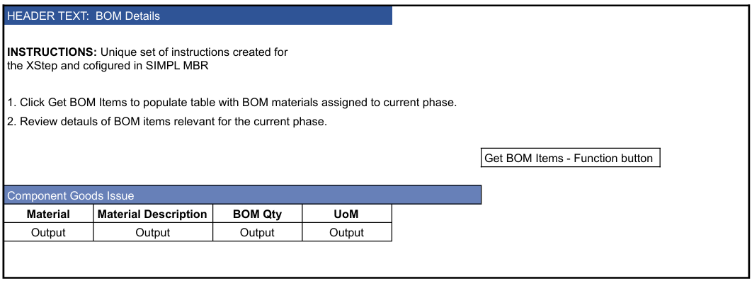

Reasons for developing
The development of the “SMPL Header: BOM Details” XStep provides the operators with a clear and structured method to retrieve and review Bill of Materials items assigned to the current production phase. This improves material traceability and ensures that the execution phase is accurately aligned with the approved recipe or master batch record.

Authorization
N/A

Assumptions/ Dependencies
 | Assumption
1 | The function module is available and returns the BOM details
2 | The function module has access to the process order data that is stored in the SAP system

XStep Layout Design
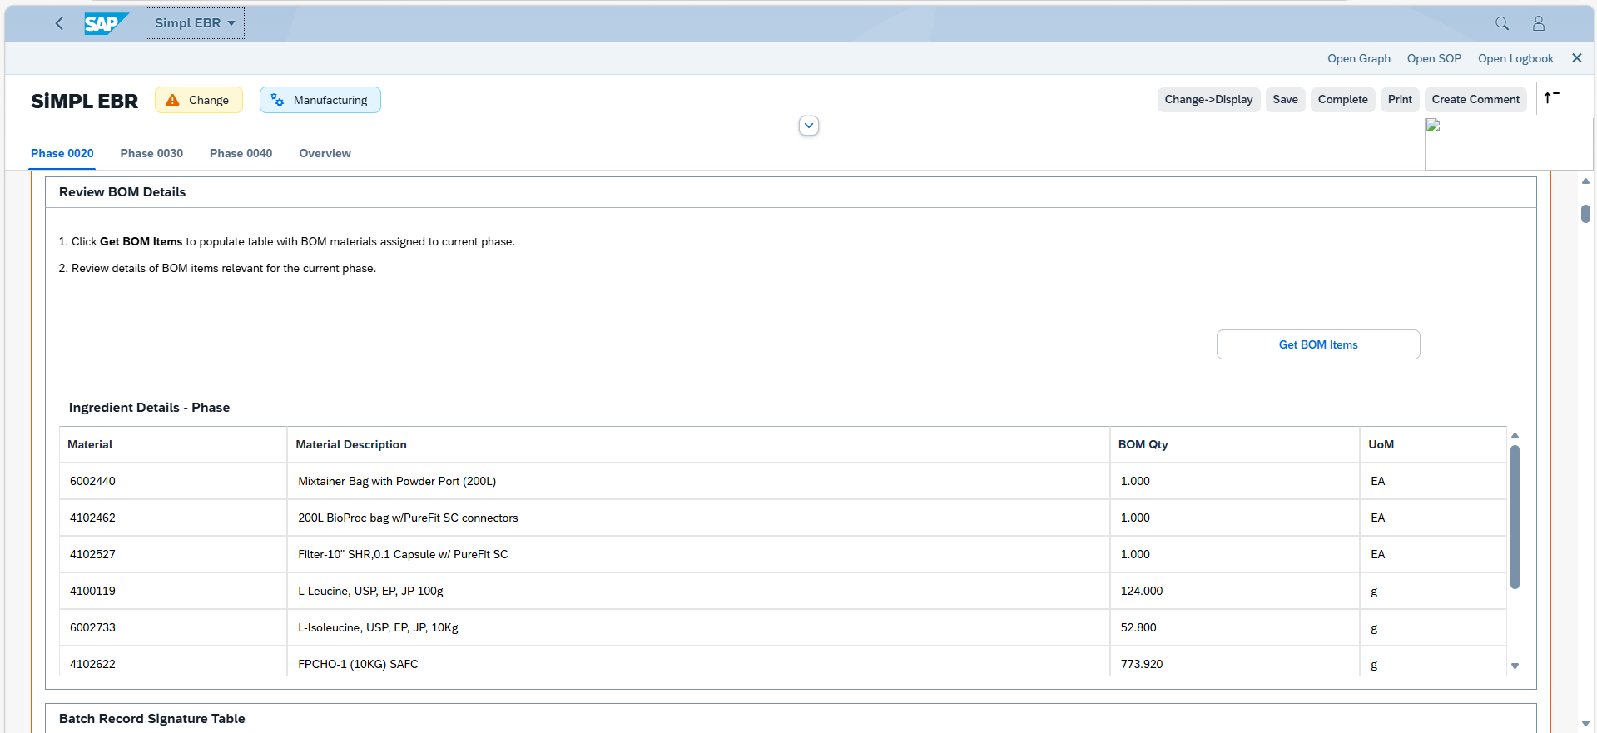

Function Module(s)
Function: ZSMPL_FM_GET_PHASE_PO_ITEMSEBR
Import Parameters:
Parameter Name | Associated Type | Short Text
IV_ORDER | AUFNR | Order Number
IV_PHASE | VORNR | Operation/Activity Number
Export Parameters:
Parameter Name | Associated Type | Short Text
ET_MATERIAL | /SMPL/STR_TT_MATNR | Table type for Materials
ET_MAT_DESC | /SMPL/STR_TT_MAKTX | Table type for Material Description
ET_BATCH | /SMPL/STR_TT_CHARG | Table type for Batches
ET_BOM_QUANTITY | /SMPL/STR_TT_ERFMG | Table type for Requested Quantity
ET_ISSUED_QUANTITY | /SMPL/STR_TT_ERFMG | Table type for Issued Quantity
ET_UOM | /SMPL/STR_TT_ERFME | Table type for Unit of Measures
ET_SERNR | /SMPL/STR_TT_SERNR | Table type for Serial Number
ET_P_MATERIAL | /SMPL/STR_TT_MATNR | Phantom Materials
ET_P_MAT_DESC | /SMPL/STR_TT_MAKTX | Phantom Material Description
ET_P_BOM_QUANTITY | /SMPL/STR_TT_ERFMG | Phantom Quantity
ET_P_UOM | /SMPL/STR_TT_ERFME | Phantom Unit of Measures

Function: /SMPL/PPPI_FM_GET_BATCH_LONG
Import Parameters:
Parameter Name | Associated Type | Short Text
IV_MATNR | MATNR | Material Number
IV_BATCH | CHARG_D | Batch Number

Export Parameters:
Parameter Name | Associated Type | Short Text
EV_BATCH_LONG | CHAR30 | 30 Characters

Function: /SMPL/PPPI_FM_INITIAL_ACTIVE
Import Parameters:
Parameter Name | Associated Type | Short Text
IV_ACTIVE | CHAR1 | N/A

Export Parameters:
Parameter Name | Associated Type | Short Text
EV_ACTIVE | CHAR1 | N/A

Function: /SMPL/PPPI_FM_INITIAL_ACTIVE
Import Parameters:
Parameter Name | Associated Type | Short Text
IV_ACTIVE | CHAR1 | N/A
Export Parameters:
Parameter Name | Associated Type | Short Text
EV_ACTIVE | CHAR1 | N/A

Function: /SMPL/MBR_DEP_CHECK_ACTIVE
Import Parameters:
Parameter Name | Associated Type | Short Text
IM_CONTROL_RECIPE | POC_DOCID | N/A
IM_PHASE | VORNR
IM_AUFNR | AUFNR
IM_STEP_UUID | /SMPL/MBR_SOG_UUID
IM_PLANT | WERKS_D

Export Parameters:
Parameter Name | Associated Type | Short Text
EV_ACTIVE | CHAR1 | N/A

Exceptions:
Exception | Short Text
CONTROL_RECIPE_INITIAL

Pseudocode
Function: ZSMPL_FM_GET_PHASE_PO_ITEMSEBR
1. Initialization
a. Define internal structures and types for managing:
- Component data
- Phantom items
- Serial number tracking
b. Set key constants for special cases:
- Serial unit of measure: EA
- Serial quantity: 1
- Movement type: 261 (Goods Issue)
- Serial origin: SER03
- Phantom item indicator: 50
c. Create required instances:
- WebSocket handler class for EBR context
- Temporary internal tables for processing logic
2. Component Source Determination
a. EBR Context (Asynchronous)
If gv_function = 'EBR' and no cached components exist:
- Use STARTING NEW TASK to call BAPI_PROCORD_GET_DETAIL asynchronously.
- Callback handled by FORM routine f_get, which populates gt_components.
b. Standard Context (Synchronous)
If not in EBR context or components are already cached:
- Call BAPI_PROCORD_GET_DETAIL synchronously.
- Store result directly in gt_components.
3. Phase-Based Component Filtering
a. Copy all components into local working table lt_components.
b. Remove entries where:
- Phase does not match input parameter iv_phase
- Required quantity = 0, unless part of a grouped reservation (same reservation number/item)
4. Loop Through Filtered Components
For each entry in lt_components:
a. Check if Material is a Phantom Item
- Read table STPO to check if ITSOB = 50 (phantom item).
- If yes, treat it as a phantom component (see section 4.c below).
- Otherwise, process as a standard component.
b. Process Standard Component
i. Append material, description, batch, BOM quantity, issued quantity, and UOM to their respective output tables.
ii. If movement type = 261 (goods issue), query MSEG to retrieve material documents associated with the order.
iii. For each document, call GET_SERNOS_OF_DOCUMENT to retrieve serial numbers:
- If none found: append blank serial entry.
- If serials found:
  - Append a blank row (for formatting in PI Sheet).
  - Append each serial number as its own entry with quantity = 1 and UOM = EA
c. Process Phantom Component
i. Add phantom material and related values to separate output tables:
- Material number
- Description
- BOM quantity
- UOM
5. Asynchronous Callback Handling (FORM f_get)
a. Callback for asynchronous BAPI_PROCORD_GET_DETAIL call.
b. Sets gt_components with returned data.
c. If triggered from EBR:
- Sends WebSocket response using if_apc_wsp_extension~on_message with message and context references.
6. Output Preparation
a. All relevant material, batch, and quantity data is populated into the following export tables:
- et_material, et_mat_desc, et_batch, et_bom_quantity, et_issued_quantity, et_uom
- Phantom-related: et_p_material, et_p_mat_desc, et_p_bom_quantity, et_p_uom
- Serial numbers: et_sernr
Additional Notes
- The function supports both foreground and asynchronous (EBR) execution.
- Phantom components are handled separately and distinctly exported.
- Serial number logic is designed for integration into PI Sheets where each serial must be shown explicitly.
- Ensures compatibility with Electronic Batch Record systems by leveraging WebSocket messaging.
- Only components relevant to a specific phase are processed.
- The logic ensures clean data presentation by appending blank lines between serial blocks.

Function: /SMPL/PPPI_FM_GET_BATCH_LONG
1. Initialization
a. Define custom structure t_cabn for characteristic data:
- atinn: Internal characteristic ID
- atnam: Characteristic name
b. Set constant values:
- c_obj_table: Object table (MCH1)
- c_class_type: Class type (023 – batch class)
- c_batch_long: Characteristic name for long batch (ZBAT_BATCH_LONG)
- c_is_set: Value indicating a field is set ('Y')
c. Declare working variables:
- l_cuobj: Internal object number for the batch
- lv_atwrt: Value of the characteristic (long batch)
- lt_ausp: Table for characteristic values
- st_ausp: Work area for lt_ausp
- st_b_long: Holds characteristic metadata for ZBAT_BATCH_LONG
- lv_matnr: Material number
2. Retrieve Characteristic Definition
a. Query table CABN to get the internal characteristic number (ATINN) for characteristic ZBAT_BATCH_LONG.
b. Store result in st_b_long.
3. Retrieve Object Number for the Batch
a. Select the internal object number CUOBJ_BM from table MCH1 using:
- IV_MATNR (material number)
- IV_BATCH (batch number)
b. Store the result in l_cuobj.
4. Get Characteristic Values for the Batch
a. Query table AUSP to retrieve the characteristic value (ATWRT) for the given CUOBJ_BM, restricted to:
- Class type 023
- Not marked for deletion (LKENZ = space)
- Valid from date (DATUV <= SY-DATUM)
- Characteristic = ZBAT_BATCH_LONG
b. Append matching entries to internal table lt_ausp.
5. Extract Long Batch Value
a. Read lt_ausp into st_ausp where the characteristic (ATINN) matches the internal ID of ZBAT_BATCH_LONG.
b. Assign the characteristic value (ATWRT) to lv_atwrt.
6. Determine Exported Batch Value
a. If lv_atwrt is not initial:
- Set EV_BATCH_LONG = lv_atwrt (use the long batch value).
b. If lv_atwrt is initial:
- Set EV_BATCH_LONG = IV_BATCH (fallback to the original batch number).
Additional Notes
- The function retrieves a long-form batch number assigned as a batch classification characteristic.
- It is dependent on:
The batch being classified in class type 023
The characteristic ZBAT_BATCH_LONG being correctly configured in the system
- If no value is found for the characteristic, the original batch number is returned as a fallback.
- No exception handling is included for missing characteristic definitions or missing batch master data—assumes standard system behavior on SELECT SINGLE.

Function: /SMPL/PPPI_FM_INITIAL_ACTIVE
1. Initialization
a. Input parameter IV_ACTIVE is optionally provided by the calling logic.
b. Constants gc_yes, gc_no, and gc_inside_range are assumed to be defined globally in the context of the function module.
2. Active Flag Evaluation
a. The function checks if the input value IV_ACTIVE falls within the expected valid range, represented by gc_inside_range.
b. Based on the result:
- If the input value is not equal to gc_inside_range, the XStep is marked as inactive by setting EV_ACTIVE = gc_no.
- If the input value is equal to gc_inside_range, the XStep is marked as active by setting EV_ACTIVE = gc_yes.
3. Output Assignment
a. The evaluated result is returned in the EV_ACTIVE export parameter for use by the calling logic (e.g., XStep configuration, PI sheet rendering).
Additional Notes
- This is a simple normalization function that abstracts how activation flags are interpreted for PPPI XSteps
- The use of constants (gc_yes, gc_no, and gc_inside_range) allows the logic to be aligned with broader application settings or standards.
- Helpful in scenarios where input values may vary but need to result in consistent "active" or "inactive" behavior.
- Input is optional, so defaulting behavior can be configured outside this function.
- This function improves clarity and consistency in determining whether an XStep should be active when rendered in the PI Sheet.

Function: /SMPL/MBR_DEP_CHECK_ACTIVE
1. Initialization
a. Input parameters provide context for determining whether an MBR (Manufacturing Batch Record) step can be activated:
- IM_CONTROL_RECIPE (POC_DOCID) – Control recipe ID identifying the batch instruction.
- IM_PHASE (VORNR) (Optional) – Operation or phase within the process order.
- IM_AUFNR (AUFNR) (Optional) – Process order number associated with the step.
- IM_STEP_UUID (/SMPL/MBR_SOG_UUID) – Unique step identifier (SOG).
- IM_PLANT (WERKS_D) – Plant code for process context.
b. The function first validates that IM_CONTROL_RECIPE is not initial.
- If it is initial, the exception CONTROL_RECIPE_INITIAL is raised.
c. Internal data is initialized:
- lt_ord_sigs: Internal table for storing order signature data from /SMPL/MBR_OR_SIG.
- ls_step_dep: Work area for step dependency data.
- Routine LOAD_INTERNAL_DATA is called to populate internal buffers (g_ord_data-t_ord_deps) using IM_AUFNR, IM_CONTROL_RECIPE, and IM_STEP_UUID.
2. Signature Data Retrieval
a. The function retrieves signature records for the process order from database table /SMPL/MBR_OR_SIG.
b. Selected fields include: AUFNR, SOG_UUID, TYPE, CREATED_DATE, CREATED_TIME, DEST_NAME, SIGN_ID, SIGN_DATE, and SIGN_TIME.
c. Only signatures related to the specified order (AUFNR = IM_AUFNR) are selected.
d. These records are stored in the internal table lt_ord_sigs for later evaluation.
3. Dependency Evaluation
a. The function loops through dependencies in g_ord_data-t_ord_deps where:
- TARGET_UUID = IM_STEP_UUID, and
- DEP_RULE is either gc_perform_before_start_rule or gc_verify_before_start_rule.
b. For each dependency record:
- If the rule is PERFORM BEFORE START, it checks whether the prerequisite step (PREREQ_UUID) has a pending perform signature (gc_perform_signature) with SIGN_ID = abap_false.
- If the rule is VERIFY BEFORE START, it checks whether the prerequisite step (PREREQ_UUID) has a pending verify signature (gc_verify_signature) with SIGN_ID = abap_false.
c. If an incomplete signature is found, the step is marked inactive (EV_ACTIVE = gc_step_inactive).
d. If all prerequisite signatures are complete, the step is marked active (EV_ACTIVE = gc_step_active).
4. Output Assignment
a. The evaluated activation status is returned in the export parameter EV_ACTIVE.
- gc_step_active – All prerequisite steps are completed; the current step can start.
- gc_step_inactive – At least one prerequisite step is incomplete; the current step remains blocked.
Additional Notes
This function determines whether a dependent step in a Manufacturing Batch Record is eligible to start based on the completion of prerequisite steps.
Key Features:
- Evaluates Perform Before Start and Verify Before Start dependency rules.
- Dynamically validates signature data from /SMPL/MBR_OR_SIG.
- Integrates with existing MBR dependency structures via global table g_ord_data-t_ord_deps.
Error Handling:
- Raises CONTROL_RECIPE_INITIAL if the control recipe input is missing.
- Handles empty dependency or signature data without runtime errors.
Dependencies:
- Tables: /SMPL/MBR_OR_SIG (Signatures), g_ord_data-t_ord_deps (Step Dependencies).
- Constants: gc_perform_before_start_rule, gc_verify_before_start_rule, gc_perform_signature, gc_verify_signature, gc_step_active, gc_step_inactive.
- Routine: LOAD_INTERNAL_DATA for initializing order context.
Assumptions:
- All prerequisite steps are recorded in the dependency table.
- Signature records are current and synchronized with MBR step progression.
- Activation status is recalculated each time the function is called to reflect live signature data.

Configuration Specification
N/A

Test Scenarios
# | Scenario | Expected Result | Actual Result | Pass/ Fail
1 | Create and Release a Process Order with the pre-configured SiMPL Master Recipe and the relevant Production Version | Process Order created and Released containing SMPL Header: BOM Details | Process Order created and Released containing SMPL Header: BOM Details
2 | Open the EBR, and navigate to SMPL Header: BOM Details | The EBR for the selected Process Order and Control Recipe opens successfully without any errors and the SMPL Header: BOM Details is visible | The EBR for the selected Process Order and Control Recipe opens successfully without any errors and the SMPL Header: BOM Details is visible
3 | The value entered in parameter IV_HEADER and parameter IV_INSTR in SiMPL MBR appears correctly in the XStep header | Header and instruction text are displayed as authored in SiMPL MBR | Header and instruction text are displayed correctly.
4 | Verify that all the relevant BOM details are populated in the table. | BOM List populates with relevant/correct information | BOM List populates with relevant/correct information

Revision History
Version No. | Description | Author | Date
1.1 | Initial Document (Functional requirements and technical specification) | Karla Uys and Frieda van der Merwe | 23-06-2025
1.2 | The following Technical Spec sections added to spec: Function Module(s), and Pseudocode. | James Church | 19-06-2026

